ANALYSTLAB AFRICA
Machine Learning Internship Programme — Week 3
Business Report
Machine Learning Model Development & Performance Evaluation — Customer Churn Prediction

1. Modelling Approach
Building on the Week 1 problem framing and the Week 2 preprocessing pipeline, this phase develops and compares supervised classification models to predict customer churn for ABC Communications Ltd. The processed dataset (7,043 customers, 25 features, fully numeric, no missing values) was split 80/20 into training and testing sets, stratified on Churn to preserve the 73.5%/26.5% class ratio in both sets. Because the classes are imbalanced, SMOTE (Synthetic Minority Over-sampling) was applied to the training set only, after the split, so the model sees a balanced 50/50 training signal while the test set retains the real-world distribution for a realistic performance read.

2. Algorithms Selected
Five classification algorithms were trained and compared, spanning a range from simple/interpretable to complex/high-capacity:
- Logistic Regression — fast, highly interpretable baseline
- Decision Tree — simple, rule-based, interpretable
- Random Forest — ensemble of trees, robust to overfitting
- Gradient Boosting — sequential ensemble, strong on tabular data
- XGBoost — optimized gradient boosting, fast and powerful

3. Evaluation Results
All five models were evaluated on the untouched test set (1,409 customers) using five standard classification metrics. Because of the class imbalance, ROC-AUC and Recall are weighted more heavily than raw Accuracy in the final recommendation — a model that simply predicts “No churn” for everyone would already score ~73.5% accuracy while being business-useless.
Model | Accuracy | Precision | Recall | F1 | ROC-AUC
Random Forest | 0.761 | 0.536 | 0.743 | 0.623 | 0.836
Logistic Regression | 0.764 | 0.543 | 0.711 | 0.616 | 0.832
Gradient Boosting | 0.770 | 0.551 | 0.717 | 0.623 | 0.830
XGBoost | 0.764 | 0.547 | 0.634 | 0.587 | 0.814
Decision Tree | 0.738 | 0.505 | 0.727 | 0.596 | 0.783
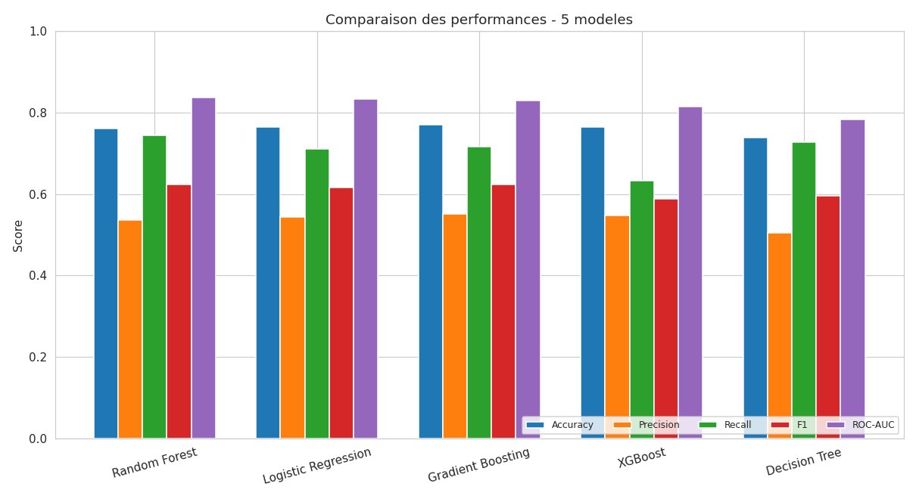
Figure 1. Performance comparison across all five models and metrics.
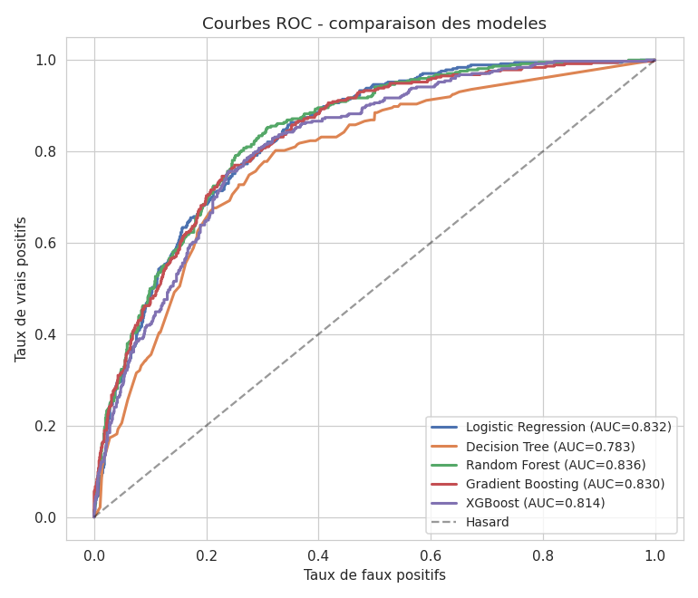
Figure 2. ROC curves — Random Forest achieves the highest area under the curve (0.836).

4. Model Comparison
Model | Advantages | Limitations | Business Suitability
Logistic Regression | Fast, highly interpretable, solid baseline | Assumes linear relationships | Good — strong performance/explainability trade-off
Decision Tree | Interpretable, fast | Lowest ROC-AUC, prone to overfitting | Not recommended alone
Random Forest | Best ROC-AUC and best recall among top models, robust | Less directly interpretable, slower to train | Best overall choice
Gradient Boosting | Best precision and accuracy | Slowest to train, hyperparameter-sensitive | Good if precision is prioritized
XGBoost | Fast despite complexity | Lowest recall among ensembles | Weaker fit given recall priority

5. Feature Importance
Random Forest feature importance was used to identify the strongest churn predictors. Contract type dominates, followed by tenure, billing amounts, and internet service type.
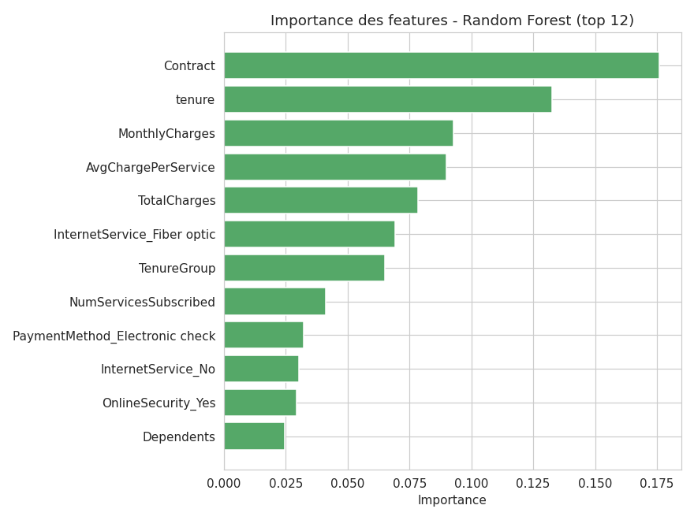
Figure 3. Top 12 features by Random Forest importance.
Business interpretation: Contract is by far the strongest predictor — month-to-month customers churn far more than those on annual contracts, making contract-upgrade incentives (discounts for 1-2 year commitments) a direct, actionable lever. Tenure confirms that the first year is the highest-risk window, supporting a dedicated new-customer retention program. Billing-related features and fiber internet service also rank highly, suggesting price sensitivity and service-quality perception are worth investigating further, particularly for fiber customers who churn more despite paying a premium.

6. Business Recommendations
- Deploy Random Forest as the churn-scoring model: it offers the best overall discriminative power (ROC-AUC 0.836) and, critically, the best recall (74.3%) among the strongest models — catching the most at-risk customers, which matters more than avoiding false alarms in a retention context.
- Target retention offers using the top features: prioritize month-to-month customers, especially within their first 12 months, and those on fiber internet with high monthly charges.
- Consider contract-upgrade incentives as a low-cost, high-leverage retention lever given how strongly Contract predicts churn.
- Use the model's probability score (not just the 0/1 label) to rank customers by risk and prioritize outreach for the highest-risk segment first.

7. Next Steps
- Hyperparameter tuning (GridSearch/RandomizedSearch) on Random Forest and Gradient Boosting to further improve recall/precision balance.
- Threshold optimization: the default 0.5 cutoff may not be business-optimal given the priority on recall — a lower threshold could catch more churners at the cost of more false positives.
- Cost-based evaluation: translate false negatives (lost customer) and false positives (wasted retention budget) into dollar terms to choose an operating threshold that maximizes expected business value.
- Pilot the model with the customer success team on a subset of the highest-risk customers before full-scale deployment.

